Practical 2: Formatting Output
Learning objectives:

- Format column output
- Create simple reports

Reference: SQL*Plus Command Reference, Chapter 12.

[You will need to format all the outputs for your assignment. Higher marks will be allocated for a report that is presented in a useful and easy to read manner.]

The following is a query from the previous lesson:
select order_no, order_date,
food_amount, gst, service_charge,
(food_amount+gst+service_charge) as Total_Bill
from food_order;
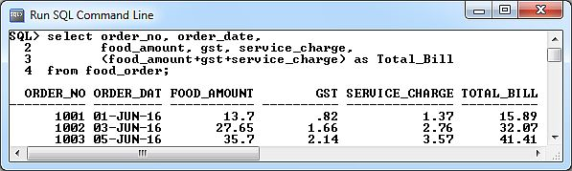

The information is useful but does not seemed “nicely” presented, especially the numbers data.

Formatting numbers:
To present numbers with the proper decimal points, execute the following SQL*Plus commands:
column food_amount format $999.99
column gst format $990.99
column service_charge format $999.99
column Total_Bill format $9,999.99

Execute the previous SQL statement and your result should look like this:
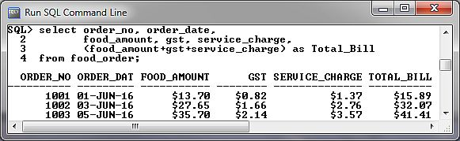

You use the COLUMN command to format the display of column headings and column data.
(Please refer to SQLPlus User's Guide and Reference Chapter 12 pg 12-26 for the various options of the COLUMN command)
Changing width of columns:
You can see that the output “ORDER_DAT” is missing the “E”. This is because the size of the data item (dd-Mon-yy) is only 9 characters wide, whereas “ORDER_DATE” is 10 characters wide. To display the column heading in full:
COLUMN order_date FORMAT A10

Now execute:
select order_no, order_date
from food_order;
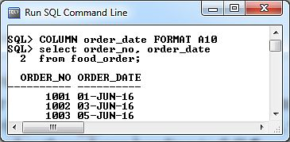

Execute this SQL statement:
select cust_no, phone, gender
from customer;

Now execute:
COLUMN cust_no HEADING "Customer No."
COLUMN phone HEADING "Tel No."
COLUMN gender HEADING "Male/Female"

Run the customer SQL query again.
Explain what happened (and suggest any improvements if any).

Clearing Column Formatting
You clear the formatting for a column using the CLEAR option of the COLUMN command.
Setting 1
column food_amount format $999.99
select order_no, food_amount
from food_order;

Setting 2
column food_amount CLEAR
select order_no, food_amount
from food_order;

What the difference between the above two settings?

You can clear the formatting for all columns using CLEAR COLUMNS. For example:

CLEAR COLUMNS
Use formatting commands to improve the following output.
select order_no, menu_id, quantity,price, quantity*price
from order_list;
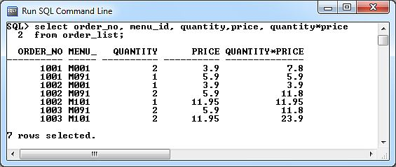

Ans:

[Reference: SQL*Plus Command Reference, Chapter 12.]

